Case Study No.: 1
Case Study Title: Drought Risk Management in Ethiopia
Author(s): Ulrich Hess
Professional Affiliation: WFP

- Short background and Synopsis of the Case Study (Sector, impacts, purpose of the financial product and how it works, stakeholder segmentation, beneficiaries of the contract, etc.)

In 2005, WFP designed the Ethiopia Drought Insurance pilot project to respond to the Government of Ethiopia’s concern that it would be trapped in a cycle of disaster response, not risk management. WFP entered into the first-ever humanitarian aid derivative contract which provided for the automatic disbursement of up to USD 7.1 million in funding if a weather index reported a significant drop in rainfall against historic averages, as this would have indicated a widespread crop failure at the end of the 2006 agricultural season. In 2007, building on this pilot, WFP is establishing a comprehensive risk management strategy around four components: Capacity building, contingency planning, contingency financing, and an early warning system with reliable financing triggers. Corresponding with the 2008–2010 Productive Safety Net Programme, Phase II includes the preparation of an integrated financial solution to coordinate financial instruments tailored to different levels of risk, thereby providing comprehensive coverage allowing us to respond to impending livelihood stress and emergencies as effectively and efficiently as possible.

WFP is already the insurer of last resort for the world’s hungry poor, but managing weather risk before disaster strikes allows WFP to further fulfil its mandate through improved emergency preparedness (both financial and operational) and effective disaster reduction. Uniquely within the United Nations system, WFP has built a leading capacity in financial disaster risk management and has a competitive advantage in harnessing the most advanced financial, technological and developmental approaches to protect vulnerable populations from natural disasters related to climate change.

In this case study we will discuss the 2005/2006 pilot project.
WFP, working with the Government of Ethiopia and other partners, put a small hedge in place on behalf of the Ethiopian agriculturalist populations vulnerable to severe and catastrophic drought. The pilot project covered Ethiopia’s 2006 agricultural season from March to October 2006, demonstrating the possibility of transferring the weather risks of least-developed countries and facilitating price discovery for Ethiopian drought risk in international financial markets. This pilot project is the first step in a process leading towards ex-ante risk management in developing countries involving governments, donors and private-sector international risk markets.
The greater timeliness of event-specific contingency funding will make aid more efficient in saving livelihoods by protecting vulnerable populations against distressed productive asset depletion in response to severe and catastrophic weather shocks. The price discovery for Ethiopian weather risk in the international risk markets will enable Ethiopia to manage weather risk more effectively, especially with regard to future climate change.

- Risks associated with meteorological, hydrological and climate conditions

Ethiopia is one of the poorest and least developed countries in the world, ranking 169th of 175 countries in the Human Development Index. More than 85% of the population makes their living in the agricultural sector which accounts 39% of Ethiopia’s GDP (2002/2003) and 78% of foreign earnings. Ethiopia’s agriculture is predominantly rain-fed and more than 95% of its output comes from subsistence and smallholder farmers.

Chronic food insecurity affects 10 percent of the population; even in normal rainfall years these households cannot meet their food needs and rely partly on food aid. As a consequence of the 2002 drought, the second most severe in recent history, a record 13 million Ethiopians required emergency assistance in 2003 at a cost of US$600 million. In the last ten years, an average 870,000 mt of food aid has been provided annually, primarily through emergency response. Millions of lives have been saved, but destitution has worsened, people’s assets have been eroded and vulnerability has increased. In the absence of a firm baseline, accurate numbers are difficult to determine but the 2002 drought appears to have pushed as many as 1–2 million previously vulnerable people into destitution.

- Segmentation of the customers for the meteorological, hydrological and climate products and services

- Customer requirements for meteorological, hydrological and climate products and services
  - Observed parameters and value-added data products (please fill in Annex 1 and add any additional parameters and indices relevant to the case)
    - Content (Parameters, frequency of observation, years of historical records, horizontal and vertical resolution, real-time updates, Metadata)

During the period commencing on 1 January 2006 and ending on 31 October 2006, NMA provided Daily Rainfall Data for each of 26 Weather Stations in the form of a digital daily spreadsheet, to WFP the Data Cleaner by e mail.

Daily Rainfall Data - was defined as cumulative rainfall data recorded at a Weather Station expressed in millimetres (mm) to one decimal (0.1) place during a Day.
Day – was defined as a period commencing on 06:00 hours (GMT) on any given day and ending immediately prior to 06:00 hours (GMT) the following day

At the end of each day, NMA HQ:
- Collected the Daily Rainfall Data from all the Weather Stations;
- Conducted a preliminary quality control of all the Daily Rainfall Data by its experts (including a check to ensure that there are no negative rainfall values or values that are obviously erroneous (e.g. a Daily cumulative rainfall values of 1000mm) and that all values are internally consistent given the Weather Station’s climatology and the data being reported by other surrounding Weather Stations);
- Updated the daily spreadsheet by adding all the Daily Rainfall Data for that Day in the relevant column for each Weather Station and delete the column containing the oldest date’s data so that on any given Day, the spreadsheet contained the Daily Rainfall Data for the last 5 Days including that Day;
- If relevant, NMA updated any previously missing data in the daily spreadsheet and corrected, if necessary, any erroneous values that have been subsequently found in previous days’ data the daily spreadsheet, with a note explaining that such changes have been made and why;
- Emailed the daily spreadsheet to WFP and to the Data Cleaner,
as soon as possible, but in any event by 14:00 hours (GMT) that day (for example, the Daily Rainfall Data for 5th January 2006 was uploaded to the spreadsheet and emailed, by the latest 14:00 hours (GMT) on 6th January 2006).

    - Format

Format for Daily Rainfall Data Spreadsheet:

Station Number | Station Name | Longitude | Latitude | [date 1] (today minus 1day) | [date 2] (today minus 2days) | [date 3] (today minus 3days) | [date 4] (today minus 4days) | [date 5] (today minus 5days)
1 | Mekelle | 13 30N | 39 29E
2 | Gonder | 12 33N | 37 25E
3 | Combolcha | 11 06N | 39 50E
4 | Alemeketema | 10 02N | 39 02E
5 | Majete | 10 27N | 39 51E
6 | Debre Markos | 10 20N | 37 40E
7 | Bahir Dar | 11 36N | 37 25E
8 | Nekemte | 9 05N | 36 27E
9 | Arjo | 8 45N | 36 30E
10 | Gore | 8 09N | 35 32E
11 | Shollagebeya | 9 03N | 39 46E
12 | Fitche | 9 48N | 38 42E
13 | Addis Ababa | 9 02N | 38 45E
14 | Narzreth | 8 33N | 39 17E
15 | Ziway | 7 56N | 38 43E
16 | Kullumssa | 8 08N | 39 08E
17 | Robe | 7 51N | 39 37E
18 | Dire Dawa | 9 36N | 41 51E
19 | Ginir | 7 08N | 40 42E
20 | Debre Zeit AF | 8 44N | 38 57E
21 | Hossana | 7 33N | 37 52E
22 | Awassa | 7 05N | 38 29E
23 | Jinka | 5 48N | 36 33E
24 | Wolaita Sodo | 6 51N | 37 45E
25 | Mirab Abaya | 6 18N | 37 47E
26 | Jimma | 70 4N | 36 50E

    - Quality assurance
A third party data cleaner, MDA Federal Inc (previously known as Earth Satellite Corporation), was retained by WFP for the purpose of verifying and cleaning the Daily rainfall Data.
    - Data improvement (Filling the gaps and homogenization)
See next section b, Requirements for statistical analysis of historical data.

    - Indices
The index was designed in 2004–2005 with technical partners; access to their data and expertise resulted in an index with 80 percent correlation with the number of food aid beneficiaries from 1994 to 2004. The index, which is an objective indicator of documented major droughts, enabled the project to quantify Ethiopia's drought risk in agricultural areas and set up financial protection to cover the extremes of the risk profile. Extension officers in the field report that the index accurately tracked rains and crops during the 2006 season.

The pilot targeted households identified as transiently food-insecure included an estimated 5 million people. The index covered an area in which 17 million people live in 278 woredas (administrative districts) in Ethiopia, which can be associated with 26 class 1 weather stations. A small financial hedge was established by contract that would provide a maximum payout of US$7.1 million covering 62,000 households or 310,000 beneficiaries during the 2006 agricultural season. The average income loss of this population is US$28 million per year, with a maximum loss of US$80 million in 1984 and a theoretical worst-case potential loss of US$154 million. This is the cost of the loss to the population, not the cost of the operation to transfer that value to them. For this pilot project, pastoralists will not be covered because of the difficulty in obtaining demographic and weather data for the areas in which they are concentrated.

    - Delay in delivery of different levels of value-added data (raw data quality assured, improved data)

If, following the end of a Day, NMA HQ was unable to collect a Daily Rainfall Data from any Weather Station, then NMA up-dated the daily spreadsheet to the extent it could and emailed the daily spreadsheet to WFP and the Data Cleaner together with a note referring to the Weather Stations for which the Daily Rainfall Data was not available by 14:00 hours (GMT) that day. NMA up-dated and emailed the daily spreadsheet with the missing Daily Rainfall Data the following day to WFP and the Data Cleaner, but in any event by 14:00 hours (GMT) that day (for example, the Daily Rainfall Data for 5th January 2005, was uploaded, by the latest 14:00 hours (GMT) on 7th January 2005).

If NMA failed to record the Daily Rainfall Data for any Weather Stations, then NMA would have notified WFP and the Data Cleaner together with the daily update that the data was missing and irrecoverable, explaining the problem at the station, indicating if such problem was remediable or otherwise and if remediable, with a detailed explanations (to the extent such information are immediately available) as to what would have needed to be done and the estimated time required to remedy the problem. In such circumstances, NMA would have remedied such problems as soon as possible so that it could report Daily Rainfall Data again and would keep WFP and the Data Cleaner informed of the remedial plan and when it is likely to be able to commence reporting from the relevant Weather Station again.

If any Weather Station had ceased to report for a period of more than 3 Days, then at the request of WFP, NMA and WFP would have discussed a replacement weather station.

    - Delivery methods and data management and access interfaces
NMA provided Daily Rainfall Data for each of 26 Weather Stations in the form of a digital daily spreadsheet, to WFP the Data Cleaner by email.

    - Technical data support services
See next section b, Requirements for statistical analysis of historical data.

  - Requirements for statistical analysis of historical data

NMSA in Addis Ababa controls and monitors 600 weather stations in Ethiopia. Of these, 17 are 24 hour synoptic (SYNOP) stations, which report every three hours to WMO Global Telecommunication System (GTS), when communication permits; an additional 50–60 stations report daily to the Addis Ababa office. NMSA plans to increase its observation network to 2,500 stations, 200 of which will be Class 1. Historical data is available from the NMSA data centre in Addis Ababa; historical datasets for Class 1 stations were made available to the project team in soft copy in daily resolution. Years of civil war have limited historical data from some regions, however: several stations in the Tigray region, particularly in the north, have data missing for four to five years in the early 1990s; other regions have one or two years of data missing in the early 1990s. Despite these gaps, most stations were established in the mid-1970s or earlier and there are several stations with complete 30-year or 50-year records.

In view of the constraints outlined above, the pilot project only uses Class 1 stations with good historical data. As the premium associated with weather-risk management strategies is based on a sound actuarial analysis of the underlying risk, the quality of historical and on-going weather data is paramount. To implement a successful weather-risk management programme, the data used to construct the underlying weather indices must adhere to strict quality requirements, including:
􀂾 reliable daily collection and reporting procedures;
􀂾 daily quality control and cleaning;
􀂾 an independent source of data for verification such as GTS weather stations; and
􀂾 a long, clean and internally consistent historical record to allow for actuarial analysis of the weather risks involved – at least 30 years of daily data is ideally required.

A preliminary study of the historical data identified 44 Class 1 stations well distributed around the country (see Figure 1; Table 1 which potentially meet the above criteria. To ensure that the data from these stations was of the required quality, WFP retained Earth Satellite Corporation (EarthSat) and Risk Management Solutions (RMS) to perform data cleaning of precipitation data for the 44 locations and for 162 surrounding stations from the NMSA acquired by WFP. Data cleaning is a process in which raw weather data is analysed to identify missing values and values that are likely to be erroneous; once these have been identified they are replaced with values that represent a best estimate of the actual weather. The final dataset consisted of data for 42 of the 44 stations, with no missing values in the cleaned data. EarthSat/RMS described the quality of the final dataset as “excellent” when compared with similar precipitation datasets for other developing countries, and on a par with the quality of cleaned precipitation data available for some European countries.

Figure 1: Location of the Class 1 Weather Stations Whose Data was

Cleaned for the Insurance Project
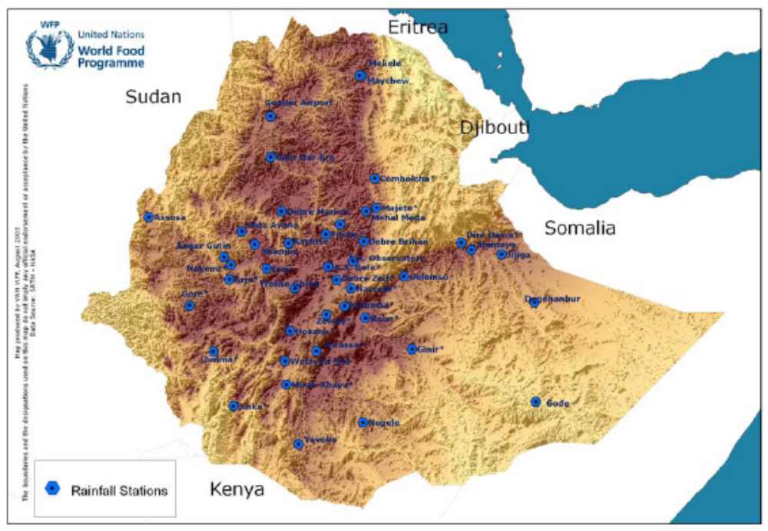

TABLE 2: ETHIOPIA WEATHER STATIONS SHORT-LISTED FOR THE INSURANCE PROJECT
Station code | Station name | Zone | Latitude (dec) | Longitude (dec) | Elevation (m) | Station establishment (year) | Cleaned: start date | Cleaned: end date | % daily missing from 1974**
0104030 | Maychew | Southern | 13.5000 | 39.5333 | 2 360 | 1975 | 1992-04-01 | 2004-06-30 | 49.47
0104031 | Mekele Airport* | Mekele | 13.5000 | 39.4833 | 2 070 | 1963 | 1992-01-01 | 2004-06-30 | 12.53
0301100 | Gonder Airport* | North Gonder | 12.5500 | 37.4167 | 1 967 | 1952 | 1980-01-01 | 2004-06-30 | 0.56
0304090 | Combolcha* | South Wello | 11.1000 | 39.8333 | 1 903 | 1958 | 1981-01-01 | 2004-06-30 | 0.14
0305020 | Alem Ketema* | North Shewa | 10.0333 | 39.0333 | 2 280 | 1973 | 1974-01-01 | 2004-06-30 | 0.00
0305050 | Majete* | North Shewa | 10.4167 | 39.8833 | 2 000 | 1962 | 1974-01-01 | 2004-06-30 | 0.00
0306080 | Debre Markos* | West Gojam | 10.3333 | 37.6667 | 2 515 | 1953 | 1974-01-01 | 2004-06-30 | 0.00
0306081 | Mehal Meda | North Shewa | 10.3333 | 39.6333 | 3 040 | 1980 | 1974-05-01 | 2004-06-30 | 1.08
0307042 | Bahr Dar branch office* | West Gojam | 11.6000 | 37.4167 | 1 770 | 1994 | 1986-01-01 | 2004-06-30 | 0.17
0402030 | Gida Ayana | East Wellega | 9.8667 | 36.7500 | 1850 | 1958 | 1981-01-01 | 2004-06-30 | 5.44
0402080 | Kachise | W/Shewa | 9.5833 | 37.8333 | 2 520 | 1955 | 1986-04-01 | 2004-06-30 | 30.94
0402100 | Shambu | Eastern Wellega | 9.5667 | 37.0500 | 2 430 | 1950 | 1987-02-01 | 2004-06-30 | 33.08
0402140 | Anger Gutin | East Wellega | 9.2667 | 36.3333 | 1 350 | 1972 | 1979-02-01 | 2004-06-30 | 9.10
0402141 | Nekemt* | Eastern Wellega | 9.0833 | 36.5000 | 2 080 | 1970 | 1980-01-01 | 2004-06-30 | 0.05
0403050 | Arjo* | East Wellega | 8.7500 | 36.4500 | 2 565 | 1955 | 1979-01-01 | 2004-06-30 | 0.91
0403110 | Gore* | Illubabor | 8.1500 | 35.5333 | 2 002 | 1952 | 1979-01-01 | 2004-06-30 | 0.59
0405050 | Ejaji | West Shewa | 9.0000 | 37.3167 | 1 900 | 1965 | 1983-05-01 | 2004-06-30 | 18.31
0405100 | A.A. Bole* | 3 | 9.0333 | 38.7667 | 2 354 | 1955 | 1954-01-01 | 2004-06-30 | 0.00
0405101 | Shola Gebya* | North Shewa | 9.1667 | 39.3333 | 2 500 | 1962 | 1962-03-01 | 2004-06-30 | 0.00
0405110 | Fitche* | North Shewa | 9.8000 | 38.7000 | 2 750 | 1954 | 1973-03-01 | 2004-06-30 | 0.00
0405120 | A.A. Observatory | 1 | 9.0333 | 38.7500 | 2 408 | 1944 | 1954-01-01 | 2004-06-30 | 0.00
0406100 | Debre Brihan | North Shewa | 9.6333 | 39.5833 | 2 750 | 1956 | 1975-01-01 | 2004-06-30 | 1.38
0407030 | Nazreth* | Eastern Shewa | 8.5500 | 39.2833 | 1 622 | 1963 | 1972-01-01 | 2004-06-30 | 0.00
0407090 | Zeway* | Eastern Shewa | 7.9333 | 38.7167 | 1 640 | 1968 | 1975-01-01 | 2004-06-30 | 0.00
0408030 | Gelemso | East Hararge | 8.8167 | 40.5167 | 1 940 | 1962 | 2002-01-01 | 2004-06-30 | 33.87
0408060 | Kulumsa* | Arsi | 8.1333 | 39.1333 | 2 200 | 1963 | 1975-01-01 | 2004-06-30 | 0.00
0408140 | Robe* | Arsi | 7.8500 | 39.6167 | 2 400 | 1968 | 1980-01-01 | 2004-06-30 | 1.73
0410040 | Jijiga | Jijiga | 9.3333 | 42.7833 | 1 775 | 1968 | 2000-01-01 | 2004-06-30 | 47.03
0410060 | Alemaya | East Hararge | 9.4333 | 42.0833 | 2 125 | 1954 | 1997-01-01 | 2004-06-30 | 26.38
0410110 | Dire Dawa* | Dire Dawa | 9.6000 | 41.8500 | 1 260 | 1952 | 1980-01-01 | 2004-06-30 | 0.13
0411150 | Ginir* | Bale | 7.1333 | 40.7000 | 1 750 | 1959 | 1981-01-01 | 2004-06-30 | 0.83
0412051 | Yavello | Borena | 4.9167 | 38.0667 | 1 740 | 1980 | 1987-01-01 | 2004-06-30 | 31.70
0413010 | Negele | Borena | 5.4167 | 39.5667 | 1 544 | 1966 | 1993-01-01 | 2004-06-30 | 7.33
0504020 | Degehabour | Degehabour | 8.2167 | 43.5500 | 1 070 | 1968 | 1997-03-01 | 2004-06-30 | > 20.30
0508040 | Gode | Kebri Dehar | 5.9000 | 43.5833 | 295 | 1967 | 1993-08-01 | 2004-06-30 | 29.97
0603030 | Assosa | Assosa | 10.2000 | 34.5833 | 1 600 | 1850 | 2000-01-01 | 2004-06-30 | 25.53
0701010 | Woliso/Ghion | W/Shewa | 8.5500 | 37.9833 | 2 000 | 1962 | 1983-05-01 | 2004-06-30 | 30.59
0701050 | Debre Zeit* | Eastern Shewa | 8.7333 | 38.9500 | 1 900 | 1951 | 1965-01-01 | 2004-06-30 | 0.00
0702040 | Hosana* | Hadiya | 7.5500 | 37.8667 | 2 200 | 1953 | 1972-03-01 | 2004-06-30 | 0.00
0704021 | Awassa* | Sidama | 7.0833 | 38.4833 | 1 750 | 1972 | 1972-08-01 | 2004-06-30 | 0.00
0707030 | Jinka* | South Omo | 5.8000 | 36.5500 | 1 480 | 1983 | 1979-01-01 | 2004-06-30 | 0.69
0708030 | Wolayita Sodo* | Wolayita | 6.8500 | 37.7500 | 1 800 | 1962 | 1972-01-01 | 2004-06-30 | 0.00
0708040 | Mirab Abaya* | Norh Omo | 6.3000 | 37.7833 | 1 260 | 1972 | 1972-03-01 | 2004-06-30 | 0.00
0709040 | Jimma* | Jimma | 7.0667 | 36.0833 | 1 725 | 1952 | 1980-01-01 | 2004-06-30 | 0.19

*Starred stations are part of the final 26.
**Up to June 2004, including cleaned data where available.
The Vulnerability Analysis and Mapping (VAM) Unit used spatial analysis techniques to assign woredas (districts) and hence rural populations to the 42 rainfall stations listed in Table 1. The objective was to find woredas whose normalized difference vegetation index (NDVI) patterns correlated with rainfall recorded at each of the 42 stations. The geographic layers used to perform the analysis were:
- 42 geo-referenced rainfall stations (source: NMSA);
- NDVI for 36 decads per year from 1998 to 2003 (Source: SPOT Vegetation, 1 km² resolution); and
- elevation (source: GTOPO30 USGS).

Rainfall data for each station was analysed to retrieve the rainfall average per decad in 1984–2004, giving the rainfall “signature” for that location. To identify the area represented by a given rainfall station, NDVI averages for the 36 decads from 1998−-003 were classed into ten clusters representing geographical areas that exhibited similar NDVI patterns throughout the year. The clusters were created by an unsupervised classification using ERDAS Imagine software to identify the ten dominant classes of NVDI variability. For each cluster, the underlying NDVI “signature” was analysed and compared with the rainfall signatures of stations in these clusters. NDVI clusters, woredas and each rainfall station were then combined to calculate the area represented by each NDVI cluster for which the rainfall station was representative. The following criteria were used to assign the woredas to rainfall stations:
- the NDVI classification for the woreda and the rainfall signatures exhibit a similar pattern, i.e. they fall within the same “micro-climate”;
- the area of the woreda represented by the NDVI cluster is greater than 50 percent; and
- the woredas with more than 50 percent of area represented by the NDVI cluster must be contiguous to other such woredas to be considered as represented by the station.
For some stations in the higher-producing and enset (false banana) growing regions in the southwest, where extended and reliable rainfall seasons allow for multiple sowing seasons, NDVI was found not to be the best indicator for assigning woredas to weather stations – that is, the NDVI “signature” in these areas did not correspond well with the rainfall station signatures. In these cases, only criteria (ii) and (iii) were used. In all cases, however, the woredas assigned to the 42 weather stations by the methodology outlined above corresponded extremely well when a correlation analysis was performed on rainfall data using all Class 1 NMSA weather stations. Rainfall data from stations within the same NDVI cluster exhibited good temporal correlations with other stations in the same cluster and exhibited weaker correlations with those outside the cluster.

To identify which of the woredas associated with the 42 weather stations were predominantly agricultural, geographical masks were used to extract the season type for each woreda. Three masks were provided in Arc/Info Export Grid format from the United States Geological Survey (USGS)/Famine Early-Warning Systems Network (FEWS-NET). The first outlined the belg areas, the second outlined the predominantly kiremt (major rainfall season; meher growing season) areas and the third outlined regions thought to be long-cycle cereal-growing areas (March/April−October/November). The long-cycle regions were mapped by USGS/FEWS-NET using climatological ratios of precipitation and potential evaporation, aided by reference to the Crop Production System Zones (CPSZ) of the Food and Agriculture Organization of the United Nations (FAO).
Using information from the masks, only woredas and stations with an area greater than 50 percent falling in a kiremt zone were kept for the subsequent risk analysis; these areas were thus defined as agricultural. Of the remaining woredas, those with an area greater than 50 percent falling in the long-cycle zone were labelled long-cycle crop growing woredas, areas whose climate enables production of high-yield, slow-maturing long-cycle crops such as maize, sorghum and millet. Woredas with an area less than 50 percent falling in the long-cycle zone were labelled short-cycle crop growing woredas, areas whose climate enables only production of low-yield short-cycle crops such as wheat, teff (a staple grain crop), barley and short-cycle variants of maize and sorghum. Of the 42 stations initially considered, therefore, only 26 were finally selected for the pilot project (see Table 2). These are stations with the longest historical records and available cleaned data located in agricultural areas identified according to the criteria outlined above. In total, 278 woredas were associated with these stations by the spatial analysis (see figure 2).
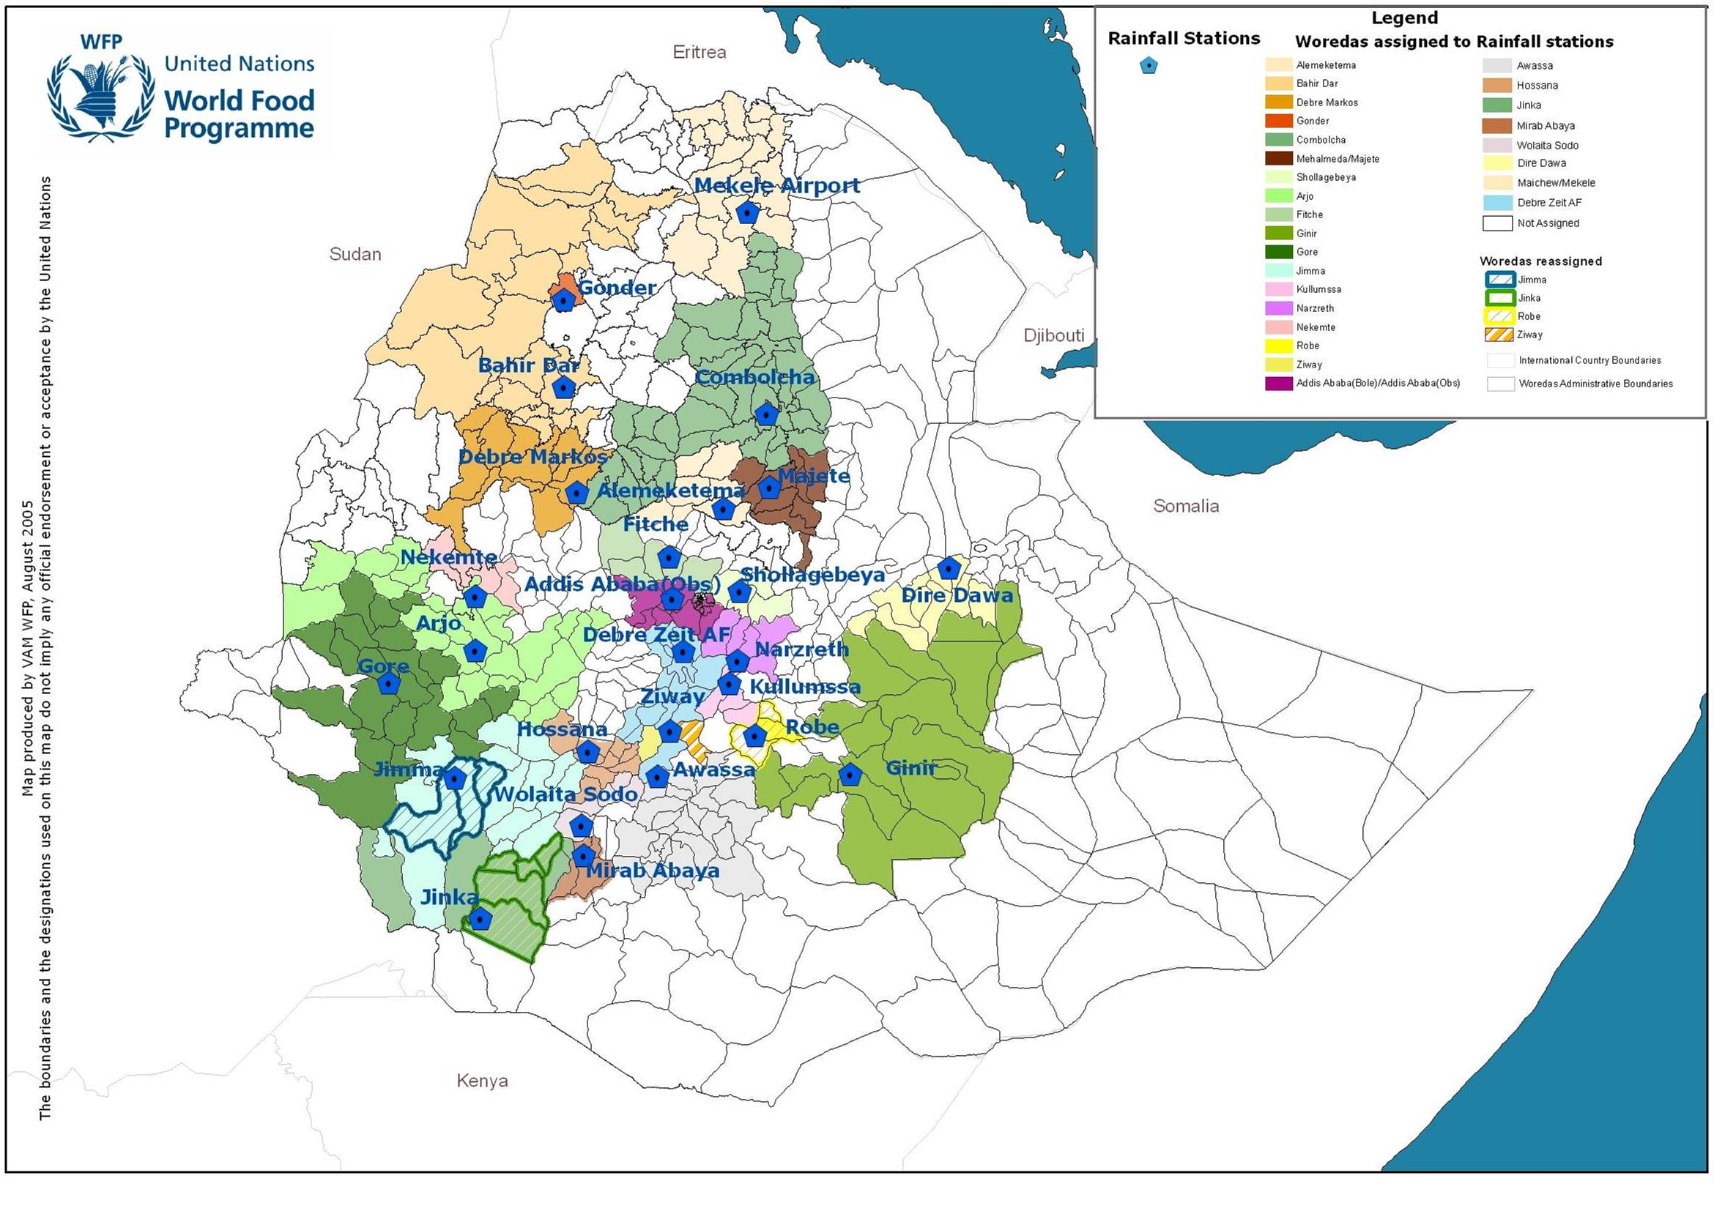
Figure 2: Map of Woredas Associated with Stations Used in the Index

- Other relevant issues

Following approval of the project, WFP worked with NMA in preparation for its responsibilities as the data provider for the Ethiopia drought insurance project. This involved ensuring that radios and full-time dedicated and trained staff were available at each of the 26 stations and that procedures were in place for the daily reporting of data to NMA headquarters in Addis Ababa, and from there to the designated settlement data provider — Washington-based MacDonald, Dettweiler and Associates Ltd (MDA) Federal Inc. (formerly EarthSat).

From 1 January 2006, NMA reliably reported daily rainfall data for each of the 26 weather stations via e-mail to MDA Federal, which validated the data and passed them on to WFP and AXA Re every day. This improved capacity allowed the NMA to report regularly to the United Nations World Meteorological Organization Global Telecommunication System for the first time in four years.

In terms of crop production, 2006 was a good year in Ethiopia. The available information is limited in that assessments of crop supply and food access for 2006 are still not available. Nevertheless, lessons can be learned from the field-level verification of the index commissioned by the project. The Central Statistical Authority (CSA) forecasts indicate a harvest 16 percent better than 2005. The Ethiopia Drought Index (EDI) value for the 2006 season was US$21.1 million compared with US$41.9 million in 2005 and 30 percent better than the long-term average value (see Figure 3). The EDI value at the end of the contract period, 31 October 2006, was well below the US$55 million trigger level, indicating that a catastrophic drought of the magnitude of 2002 or 1984 did not occur in 2006. Therefore there was no payout from the weather derivative contract in 2006.

Figure 3: The Ethiopia Drought Index, 1952–2006
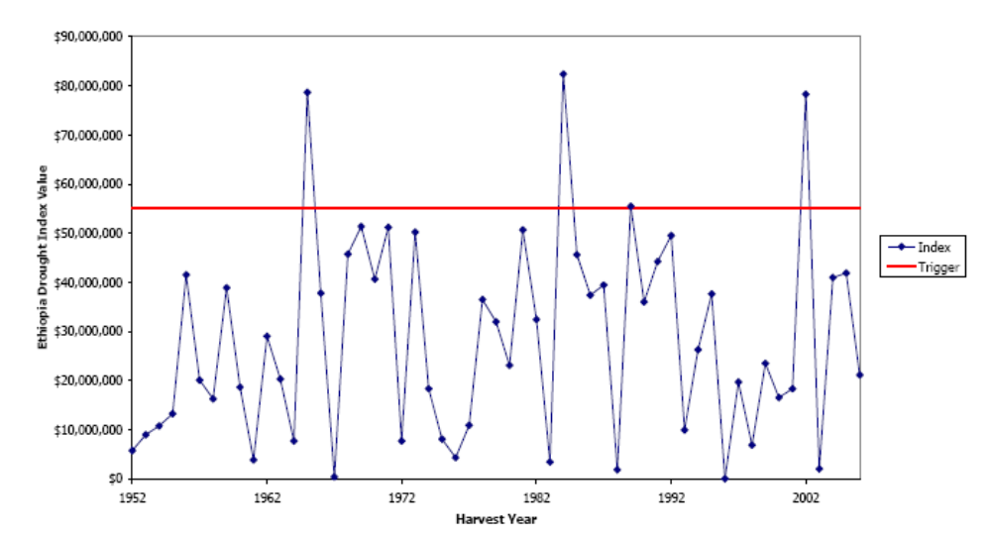

Rainfall was above average throughout the country in 2006. This resulted in three floods, but production was good overall. The EDI is not designed to capture flood or excessive rainfall, but it performed well and accurately reflected local water shortfalls where they occurred.

The EDI for the 2006 pilot was monitored during the 2006 agricultural season to check the accuracy of the rainfall index. The project team received daily rainfall updates from the NMA for each of the 26 stations. This allowed the value of the index to be updated so that it could be compared with the status of the staple crops in their areas. The fact that the season was good made it more complicated to verify the drought index. However, because the rainfall index is based on a crop/water balance model, comparison with Ministry of Agriculture and Rural Development field reports provided a rigorous check on its performance. Above all, such ground-truthing gave an opportunity to improve the pilot index for future applications.

An example of the index tracking the season is given for Dire Dawa weather station (see Figure 4). The red line – the EDI for Dire Dawa – denotes the evolution of the 2006 agricultural season at the station: the higher the red line, the greater is the impact of water stress – lack of rainfall – on crops; the red line at zero indicates no water stress. Field reports from the areas surrounding the station were collected; the following information was reported for Gurgura woreda:

Dire Dawa is a woreda with a growing season in the meher (main rainfall season, June-September); the main crop is sorghum, which accounts for 95 percent of the annually cropped area. In 2006 10,586 ha were planted; despite water stress and floods, sorghum yields were 10 percent greater than in 2005.

The rains started on time – the last week of March in low-lying areas, and the end of January in mid-altitude areas. In five peasant associations, however, the rains were two weeks late, starting in early April, and ended two weeks earlier than usual, in September. Dry spells of 10–15 days in May and July affected sorghum crops.

The flooding in August 2006 caused the highest recorded losses of life and property in Dire Dawa town and the surrounding area. Annual and perennial crops on 250 ha – 2 percent of the planted area – were destroyed, 1,000 animals were killed and irrigation, soils and water-harvesting structures were destroyed.

Figure 4. Evolution of the EDI, Dire Dawa station, 2006
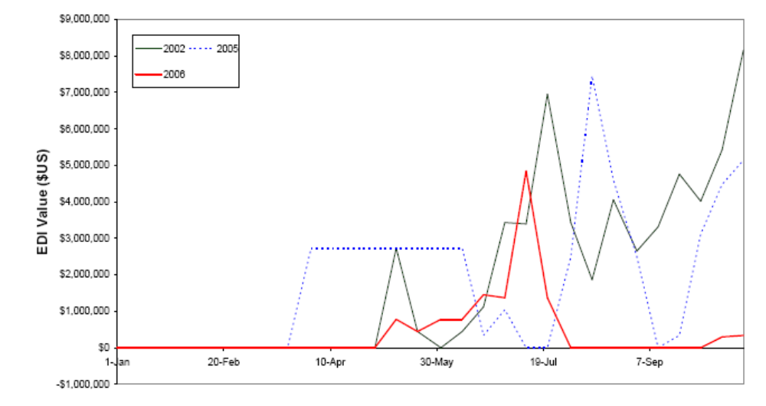

According to the EDI model for Dire Dawa, the rains started in late March; there were showers in late January. The dry spells in May and July are seen in Figure 4 as the index rises in mid-May, when sorghum crops were experiencing water stress, and again in July.

At the beginning of August the index falls to zero, indicating sufficient rainfall and recovery from the dry spells. The floods and excessive rainfall in August are not picked up: the model assumes that rainfall is desirable. Analysis of the data confirms that rainfall in August was 20 percent above the 30-year average in Dire Dawa; the river flooding resulted from excessive rainfall upstream in the Ethiopian highlands, not local rainfall.

The end of the rains in early September is also seen in Figure 4 as water stress rises slightly from mid-September. The data shows that the rains stopped two weeks earlier than the average in 2006. At the end of the season, the EDI for Dire Dawa was 11 percent higher than the 2005 value, which corresponds well with the 10 percent increase in sorghum yields observed from 2005 to 2006 by the Ministry of Agriculture and Rural Development.

Areas for refinement and improvement

Although the model accurately tracked water stress during the 2006 season, the pilot highlighted two areas where accuracy could be improved:

Crop-sowing periods. Standard FEWS-NET sowing periods for long-cycle and short-cycle crops were used to calibrate the 2006 model throughout the country. In future, however, the periods should be aligned with farming practices in each area. The 2006 model assumed, for example, that teff (a cereal used to make bread and for forage) was sown earlier than was actually the case: in some areas, teff experienced water stress because the rains ended early, but in the EDI model the crop had already been harvested and was not shown to be affected.
Length of growing cycles. Standard growing cycles from FEWS-NET and FAO were used throughout the country. But growing cycles actually vary according to altitude and local varieties: in some areas, for example, a 240-day variety of sorghum is grown, but the model assumed a standard 150-day variety. This led to discrepancies.

To address the shortfalls, the following actions are being carried out. Experts from the Ministry of Agriculture and Rural Development and the Ethiopia Agricultural Research Institute in Addis Ababa, who are reviewing the 2006 index, are compiling a database of information on sowing periods and the growing cycles of the main crops at the woreda-level in the 26 areas; they have recently finalized a zonal database of this information, which should be used in future pilots.

The project team feels that in view of the nature of the 2006 season it may be worthwhile to investigate the impacts of excessive rainfall on crop yields, even though there is no verified water-balance model to capture this; there are, however, unverified models that could be tested. The project index did not cover pastoralist areas because there were not enough usable weather stations; phase II of the project being designed with the the United Kingdom Department for International Development, United States Agency for International Development (USAID) and the World Bank will cover pastoralist areas as well.

LESSONS LEARNED:

The Ethiopia drought insurance pilot project showed that:
(i) it is feasible to use market mechanisms to finance drought risk in Ethiopia;
(ii) it is possible to develop objective, timely and accurate indicators for triggering drought assistance; the index is updated every ten days, which improves the timeliness of information on weather-related needs as they evolve; and
(iii) ex-ante resources can give governments and donors the incentive to put contingency plans in place, allowing earlier response to shocks; in drafting the implementation rulebook, the Government upgraded its contingency planning; the guarantee of predictable and reliable contingency funding catalyzed institutional interest and commitment.
 | Horizontal and vertical resolution | Frequency (observing cycle) | Min and Max Years of historical records | Need for real- (or nearly real- time observations) | Delay in availability | Level of Quality Assurance | Meta Data | Data improvements  - Filling gaps  - Homogen-ization
surface air temperature

Surface pressure
Wind (Speed and Direction)
Rainfall | 26 class 1 weather stations – which can be associated with 17 million people, living in 278 woredas (districts) in Ethiopia | Daily |  |  | Available daily | High
Snow cover, depth and water equivalent
Humidity
Surface vegetation type and cover
Cloud cover
Soil moisture
Soil Temperature
Snow melt (Run off)
Frost
Hail
Surface water discharge
Ground Water storage and fluxes
Evaporation
Sea surface temperature
Wave height, direction and period
Below sea surface (boundary layer) temperature
Tropical Cyclone (Path, land fall location, circumference of damaging wind, wind direction and speed, etc.)
Other (please specify)

These are Class 1 stations: fully equipped meteorological observing stations recording pressure, temperature, relative humidity, wind speed and direction, rainfall, evaporation and soil temperature every three hours from 06.00 to 18.00.
For example, Mekele station in Tigray region has data missing for 1989-1991 because of civil conflict. But these years were not extreme drought years.
Hess and Syroka, 2005.
EarthSat and RMS have been dealing with meteorological data since they were founded 30 and 15 years ago respectively. In particular, they have worked with the weather-derivatives industry in the last six years, supplying most of the data used. Most players in the weather market use data from EarthSat/RMS, which supply data for all countries in which weather derivatives are traded. To be able to supply official data, EarthSat has agreements with national meteorological services that allow them to obtain, clean and redistribute data. The EarthSat cleaned-data catalogue includes daily and hourly temperatures and precipitation for locations from Miami to Tokyo. The Chicago Mercantile Exchange (CME) weather-futures contracts in Europe, Japan and the United States are based entirely on data from EarthSat, which acquires it from national meteorological services, cleans it, and supplies it to CME so that it can settle contracts on a daily basis.
EarthSat/RMS were unable to produce cleaned data for the remaining two stations, Degahebour and Gode in the southeast pastoral region of Somali, because of their remoteness and the poor quality of the data.
The length of the cleaned record provided by EarthSat/RMS is a function of the number surrounding stations available at a particular time and the length of those historical records. Hence, not all station data can be cleaned from station establishment to date.
EarthSat/RMS. 2005. 5
Refer to Table 2 for station names and details.
Each month is divided into three decads, or ten-day periods; the third, from the 21st to the end of the month, can have from 8 to 11 days. For example, decad 8 is 11–20 March; decad 36 is 21–31 December.
http://edcdaac.usgs.gov/gtopo30/gtopo30.asp.
USGS at the National Centre for Earth Resources Observation and Science (EROS), Sioux Falls, SD, USA.
FEWS-NET. 2003.
Ibid
Ibid.
This number excluded urban woredas that fell in NDVI cluster groups.
This is particularly important for organizations that manage satellite-based early warning systems for Ethiopia, such as the United States Agency for International Development’s (USAID) Famine Early-Warning System Network (FEWS-NET). Real-time data from on-the-ground stations are necessary to adjust for the biases known to exist in satellite-derived rainfall estimates; the availability of such data ensures better quality early warning products for the international humanitarian aid community.
At the end of the season, the project engaged local experts from the Ministry of Agriculture and Rural Development and the Ethiopian Agricultural Research Institute in Addis Ababa to review the design of the index and carry out their own ground-truthing by visiting up to ten weather stations. Their report is not yet available; these field reports are based on the first draft.

